**WEEK 7: REACT JS**

**Exercise 9:**

**List of Players Component**

import React from 'react';

const ListofPlayers = () => {

const players = [

{ name: 'Player1', score: 85 },

{ name: 'Player2', score: 60 },

{ name: 'Player3', score: 72 },

{ name: 'Player4', score: 65 },

{ name: 'Player5', score: 55 },

{ name: 'Player6', score: 80 },

{ name: 'Player7', score: 90 },

{ name: 'Player8', score: 68 },

{ name: 'Player9', score: 50 },

{ name: 'Player10', score: 75 },

{ name: 'Player11', score: 62 }

];

const lowScoringPlayers = players.filter(player => player.score < 70);

return (

<div>

<h2>List of Players</h2>

<ul>

{players.map((player, index) => (

<li key={index}>{player.name} - {player.score}</li>

))}

</ul>

<h3>Players with Scores Below 70:</h3>

<ul>

{lowScoringPlayers.map((player, index) => (

<li key={index}>{player.name} - {player.score}</li>

))}

</ul>

</div>

);

};

export default ListofPlayers;

**IndianPlayers:**

import React from 'react';

const IndianPlayers = () => {

const [oddPlayer, evenPlayer] = ['OddPlayer', 'EvenPlayer'];

const T20players = ['PlayerA', 'PlayerB'];

const RanjiTrophyPlayers = ['PlayerX', 'PlayerY'];

const allPlayers = [...T20players, ...RanjiTrophyPlayers];

return (

<div>

<h2>Indian Players</h2>

<h3>Odd Team Player: {oddPlayer}</h3>

<h3>Even Team Player: {evenPlayer}</h3>

<h3>All Players:</h3>

<ul>

{allPlayers.map((player, index) => (

<li key={index}>{player}</li>

))}

</ul>

</div>

);

};

export default IndianPlayers;

**App Component Integration:**

import React, { useState } from 'react';

import './App.css';

import ListofPlayers from './ListofPlayers';

import IndianPlayers from './IndianPlayers';

function App() {

const [flag, setFlag] = useState(true);

return (

<div className="App">

<h1>Cricket App</h1>

{flag ? <ListofPlayers /> : <IndianPlayers />}

<button onClick={() => setFlag(!flag)}>

Toggle Components

</button>

</div>

);

}

export default App;

**OUTPUT:**

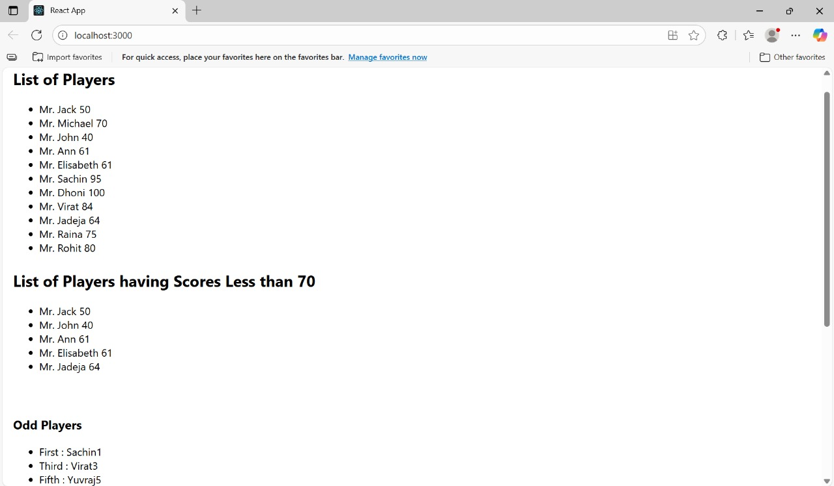

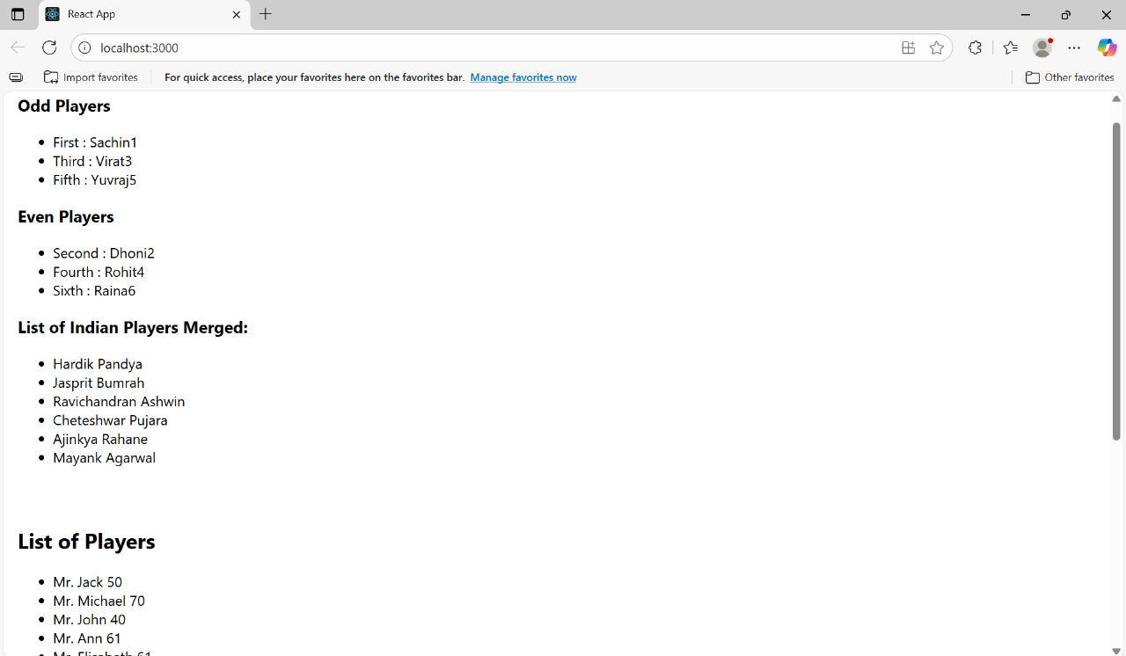

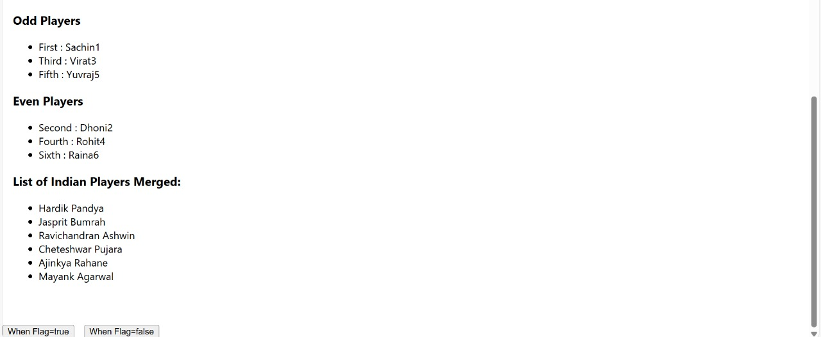

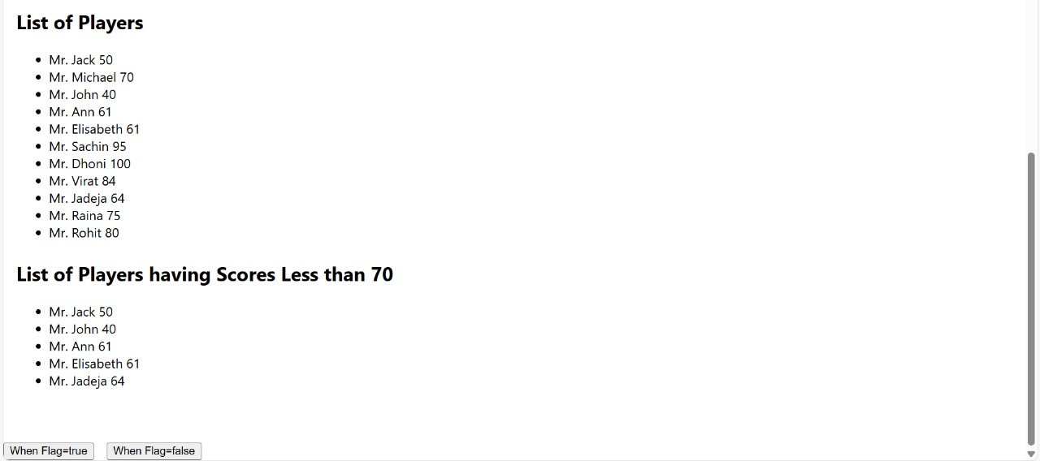

**Exercise 10:**

**App.js**

import React from 'react';

import './App.css';

function App() {

// Office Space Data - Array of Objects

const officeSpaces = [

{ id: 1, name: "Skyline Towers", rent: 55000, address: "MG Road, Bangalore", image: "https://via.placeholder.com/150" },

{ id: 2, name: "Tech Park", rent: 75000, address: "Electronic City, Bangalore", image: "https://via.placeholder.com/150" },

{ id: 3, name: "WorkSpace Hub", rent: 62000, address: "Indiranagar, Bangalore", image: "https://via.placeholder.com/150" },

{ id: 4, name: "Cozy Offices", rent: 45000, address: "Koramangala, Bangalore", image: "https://via.placeholder.com/150" },

];

return (

<div className="App">

{/* Heading using JSX */}

<h1>Office Space Rental App</h1>

{/* Rendering list of office spaces */}

<div className="office-list">

{officeSpaces.map((office) => (

<div key={office.id} className="office-card">

{/* Office Image */}

<img src={office.image} alt={office.name} />

{/* Office Details */}

<h2>{office.name}</h2>

<p>{office.address}</p>

<p

style={{

color: office.rent < 60000 ? 'red' : 'green',

fontWeight: 'bold'

}}

>

Rent: ₹{office.rent}

</p>

</div>

))}

</div>

</div>

);

}

export default App;

**App.css**

.App {

text-align: center;

padding: 20px;

}

.office-list {

display: flex;

justify-content: center;

flex-wrap: wrap;

gap: 20px;

}

.office-card {

border: 1px solid #ccc;

padding: 15px;

width: 200px;

border-radius: 10px;

box-shadow: 2px 2px 10px rgba(0,0,0,0.1);

}

.office-card img {

width: 100%;

height: auto;

border-radius: 5px;

}

**OUTPUT:**

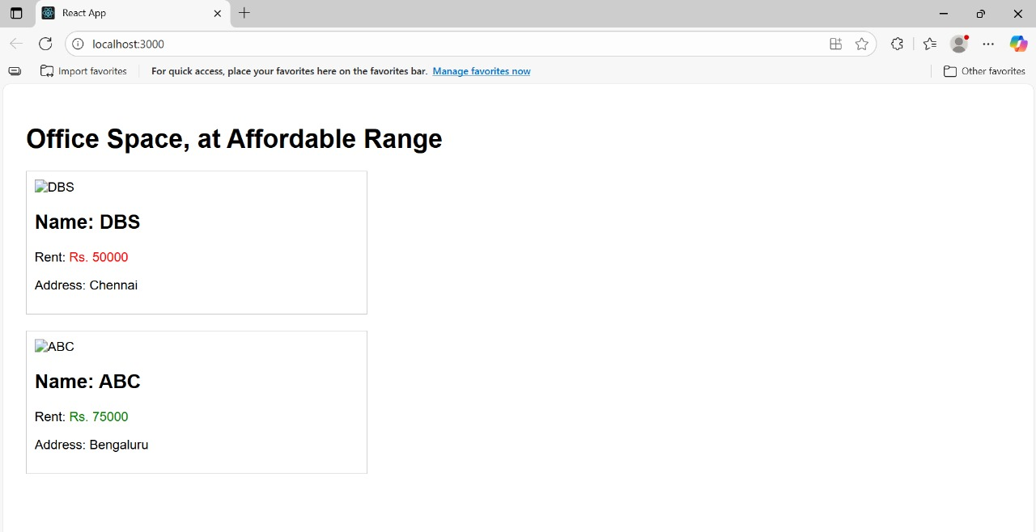

**Exercise 11:**

**Modify App.js:**

import React, { Component } from 'react';

import './App.css';

import CurrencyConvertor from './CurrencyConvertor';

class App extends Component {

constructor(props) {

super(props);

this.state = {

counter: 0

};

}

incrementCounter = () => {

this.setState({ counter: this.state.counter + 1 });

};

sayHello = () => {

alert("Hello! Welcome to Event Handling in React.");

};

handleIncrease = () => {

this.incrementCounter();

this.sayHello();

};

decrementCounter = () => {

this.setState({ counter: this.state.counter - 1 });

};

sayWelcome = (message) => {

alert(`Message: ${message}`);

};

handleSyntheticEvent = (event) => {

console.log(event); // Synthetic Event Object

alert("I was clicked");

};

render() {

return (

<div className="App">

<h1>React Event Handling Examples</h1>

<h2>Counter: {this.state.counter}</h2>

<button onClick={this.handleIncrease}>Increase</button>

<button onClick={this.decrementCounter}>Decrease</button>

<br /><br />

<button onClick={() => this.sayWelcome("Welcome to React Events!")}>

Say Welcome

</button>

<br /><br />

<button onClick={this.handleSyntheticEvent}>

Synthetic Event (Click Me)

</button>

<br /><br />

<CurrencyConvertor />

</div>

);

}

}

export default App;

**CurrencyConvertor.js:**

import React, { Component } from 'react';

class CurrencyConvertor extends Component {

constructor(props) {

super(props);

this.state = {

rupees: '',

euros: ''

};

}

handleChange = (event) => {

this.setState({ rupees: event.target.value });

};

handleSubmit = (event) => {

event.preventDefault();

const euroRate = 0.011; // Approximate Euro conversion rate

const euros = (this.state.rupees * euroRate).toFixed(2);

this.setState({ euros });

};

render() {

return (

<div>

<h2>Currency Convertor</h2>

<form onSubmit={this.handleSubmit}>

<input

type="number"

placeholder="Enter amount in INR"

value={this.state.rupees}

onChange={this.handleChange}

/>

<button type="submit">Convert to Euro</button>

</form>

{this.state.euros && (

<h3>{this.state.rupees} INR = {this.state.euros} Euros</h3>

)}

</div>

);

}

}

export default CurrencyConvertor;

**OUTPUT:**

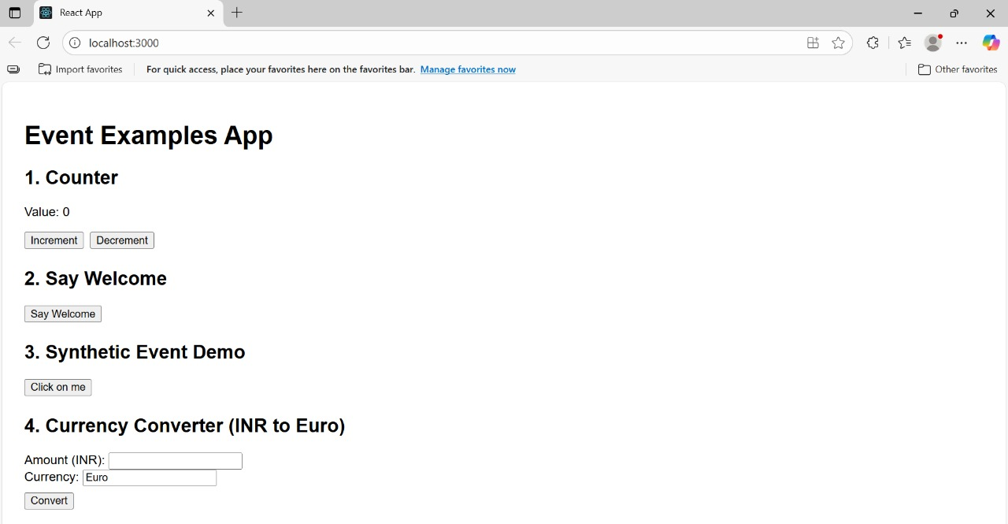

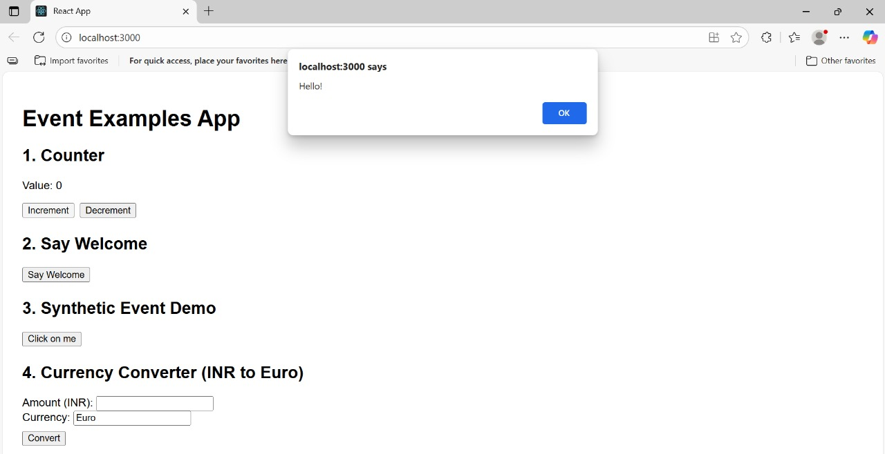

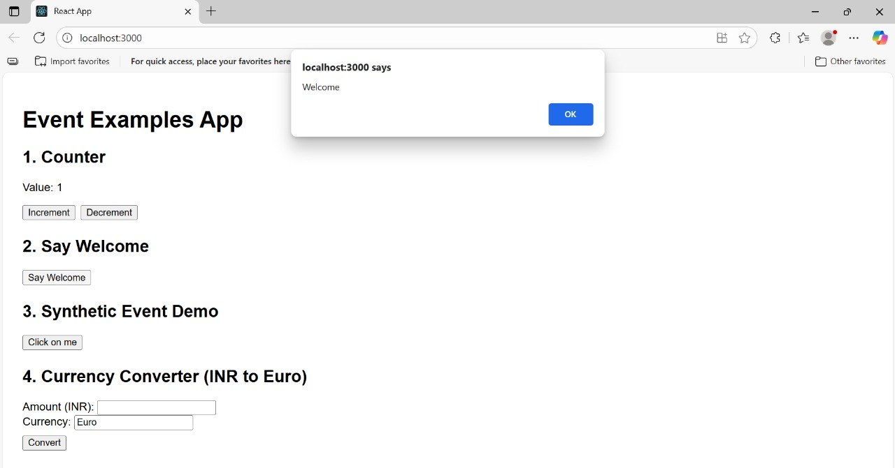

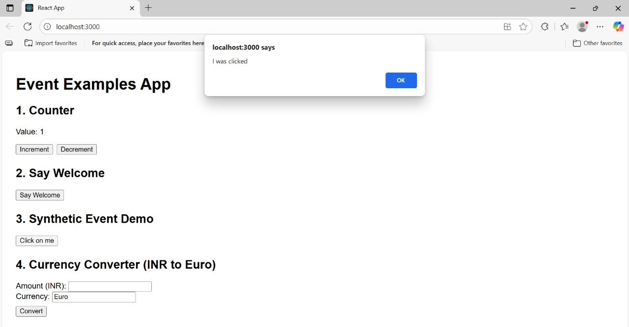

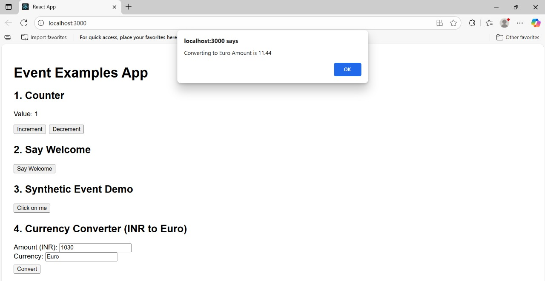

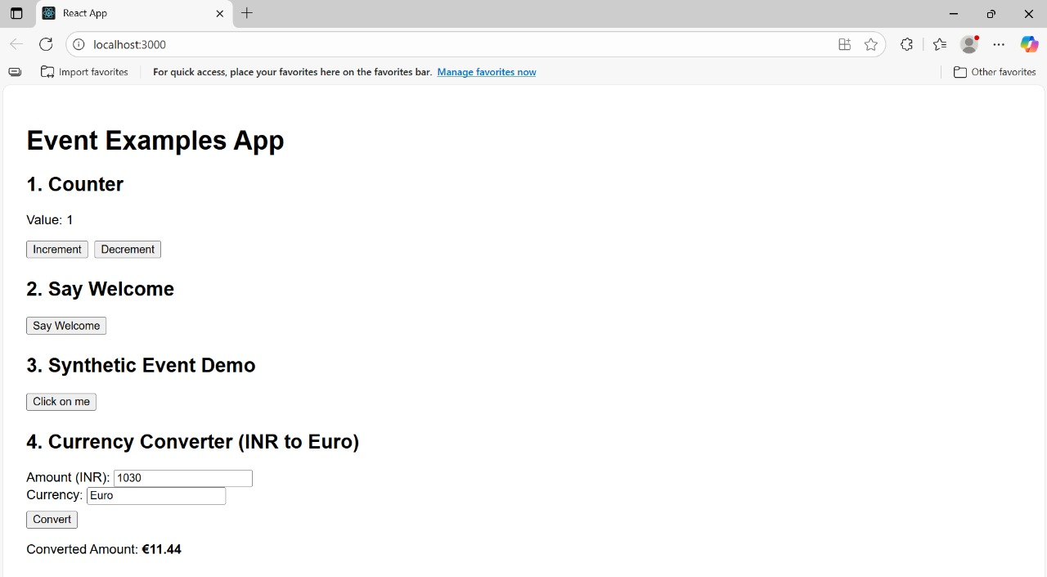

**Exercise 12:**

import React, { Component } from 'react';

import './App.css';

class App extends Component {

constructor(props) {

super(props);

this.state = {

isLoggedIn: false

};

}

handleLogin = () => {

this.setState({ isLoggedIn: true });

};

handleLogout = () => {

this.setState({ isLoggedIn: false });

};

render() {

let pageContent;

if (this.state.isLoggedIn) {

pageContent = <UserPage onLogout={this.handleLogout} />;

} else {

pageContent = <GuestPage onLogin={this.handleLogin} />;

}

return (

<div className="App">

<h1>Ticket Booking App</h1>

{pageContent}

</div>

);

}

}

function GuestPage(props) {

return (

<div>

<h2>Welcome Guest! Browse Flight Details</h2>

<FlightDetails />

<button onClick={props.onLogin}>Login to Book Tickets</button>

</div>

);

}

function UserPage(props) {

return (

<div>

<h2>Welcome User! You can book tickets now.</h2>

<FlightDetails />

<BookTickets />

<button onClick={props.onLogout}>Logout</button>

</div>

);

}

function FlightDetails() {

return (

<div>

<h3>Flight Details</h3>

<ul>

<li>Flight: AI-202 | From: Delhi | To: Mumbai | Time: 10:00 AM</li>

<li>Flight: AI-305 | From: Bangalore | To: Chennai | Time: 1:00 PM</li>

<li>Flight: AI-450 | From: Hyderabad | To: Kolkata | Time: 5:30 PM</li>

</ul>

</div>

);

}

function BookTickets() {

return (

<div>

<h3>Book Your Ticket</h3>

<p>Select your flight and proceed to payment.</p>

<button>Book Now</button>

</div>

);

}

export default App;

**OUTPUT:**

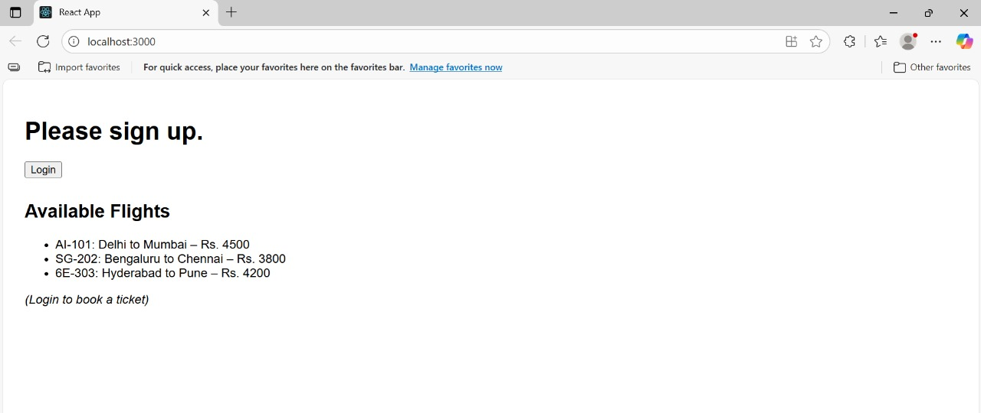

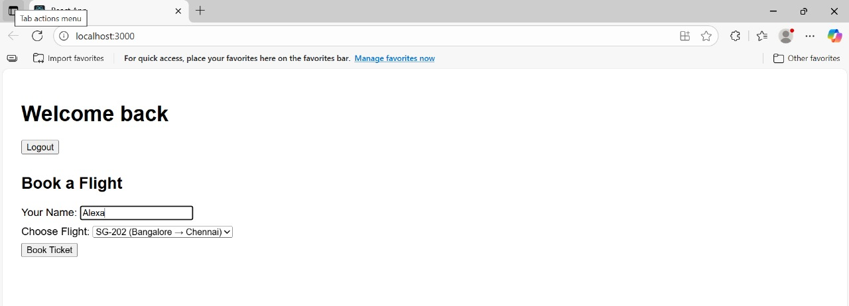

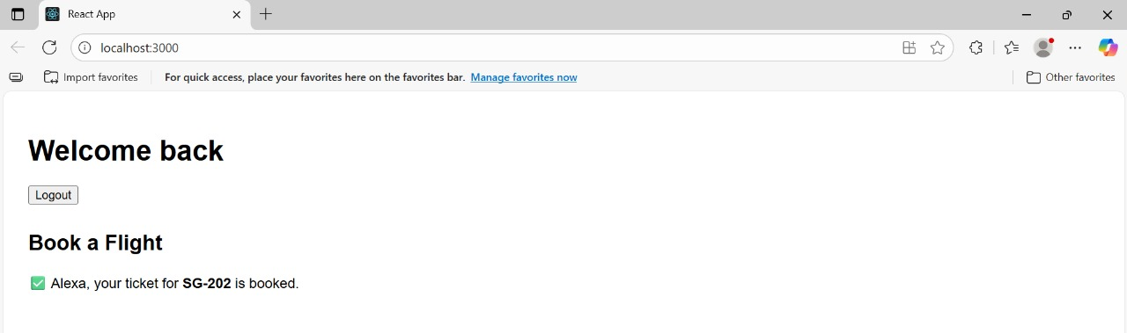

**Exercise 13:**

**BookDetails Component:**

import React from 'react';

function BookDetails({ books }) {

return (

<div>

<h2>Book Details</h2>

{books.length > 0 ? (

<ul>

{books.map((book) => (

<li key={book.id}>

{book.title} - {book.author}

</li>

))}

</ul>

) : (

<p>No Books Available</p>

)}

</div>

);

}

export default BookDetails;

**BlogDetails Component:**

import React from 'react';

function BlogDetails({ blogs }) {

return (

<div>

<h2>Blog Details</h2>

{blogs.map((blog) =>

blog.isPublished ? (

<div key={blog.id}>

<h3>{blog.title}</h3>

<p>{blog.content}</p>

</div>

) : null

)}

</div>

);

}

export default BlogDetails;

**CourseDetails Component:**

import React from 'react';

function CourseDetails({ courses }) {

return (

<div>

<h2>Course Details</h2>

{courses.length === 0 && <p>No Courses Found</p>}

{courses.length > 0 && (

<ul>

{courses.map((course) => (

<CourseItem key={course.id} course={course} />

))}

</ul>

)}

</div>

);

}

function CourseItem({ course }) {

return (

<li>

{course.name} - {course.duration} months

</li>

);

}

export default CourseDetails;

**App.js Implementation**:

import React, { useState } from 'react';

import './App.css';

import BookDetails from './components/BookDetails';

import BlogDetails from './components/BlogDetails';

import CourseDetails from './components/CourseDetails';

function App() {

const [showBooks, setShowBooks] = useState(true);

const [showBlogs, setShowBlogs] = useState(true);

const [showCourses, setShowCourses] = useState(true);

const books = [

{ id: 1, title: "React Basics", author: "John Doe" },

{ id: 2, title: "Advanced React", author: "Jane Smith" },

];

const blogs = [

{ id: 1, title: "React Hooks Explained", content: "All about Hooks...", isPublished: true },

{ id: 2, title: "React Lifecycle", content: "Understanding Lifecycle Methods", isPublished: false },

{ id: 3, title: "Conditional Rendering", content: "How to render based on conditions", isPublished: true },

];

const courses = [

{ id: 1, name: "Frontend Development", duration: 4 },

{ id: 2, name: "Backend Development", duration: 6 },

];

return (

<div className="App">

<h1>Blogger App - Conditional Rendering</h1>

<button onClick={() => setShowBooks(!showBooks)}>

{showBooks ? "Hide" : "Show"} Books

</button>

<button onClick={() => setShowBlogs(!showBlogs)}>

{showBlogs ? "Hide" : "Show"} Blogs

</button>

<button onClick={() => setShowCourses(!showCourses)}>

{showCourses ? "Hide" : "Show"} Courses

</button>

{/* Conditional Rendering using && operator */}

{showBooks && <BookDetails books={books} />}

{/* Conditional Rendering using Ternary Operator */}

{showBlogs ? <BlogDetails blogs={blogs} /> : <p>Blogs are hidden</p>}

{/* Conditional Rendering using if-else via Element Variable */}

{(() => {

if (showCourses) {

return <CourseDetails courses={courses} />;

} else {

return <p>Courses are hidden</p>;

}

})()}

</div>

);

}

export default App;

**OUTPUT:**

